//TEAM NAME

**REGISTRATION NUMBERS:**

* RA1911042010113
* RA1911042010117
* RA1911042010124

**NAME OF THE PROJECT:** BOOK REVIEW AND RECCOMENDATIONS APPLICATION

**DESCRIPTION:**

Entertainment comes in various kinds and not everything is for everybody. Some people may like certain media more than others while some might absolutely hate it. This implies that we need something that can keep track of what a person has read, how they feel about it and what they might like to see next.

The book review and recommendations application plans to achieve just that. It lets you keep track of what all you have read and lets you review the book as well. It will also suggest what you might enjoy reading next based on your past books. It saves us the time from looking for the next book to read. It also lists other users’ reviews to help the user decide if they really want to read it next. This will save time and energy of the user and lead them to their next favorite as soon as possible.

In today’s world where leisure time is limited and entertainment is abundant, we must utilize the time experiencing the media rather than look for them. An application which deals with that for you will certainly be well appreciated.

**BLOCK DIAGRAM:**

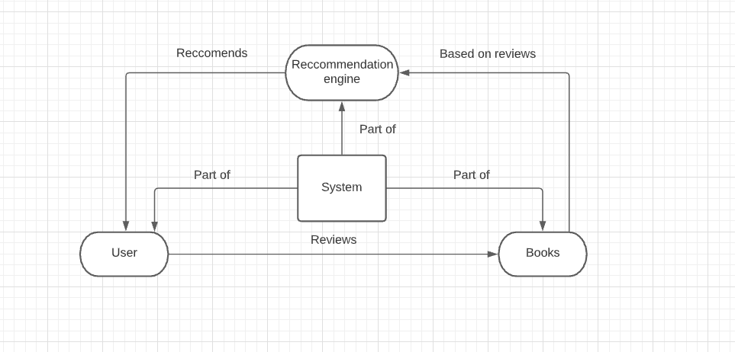

**EXPECTED OUTCOME:**

* Creating a database with lots of popular books
* Letting users review them
* Recommending books to users based on reviews and past behaviors

**Plan and action (Gantt Chart):**

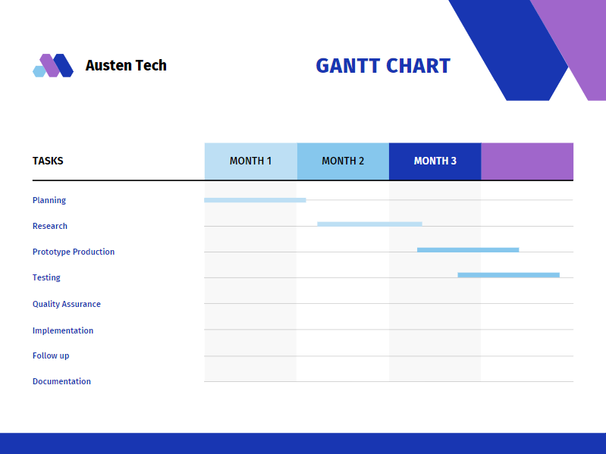

**Completion / workshop planned to attend:**

TBD

**Conclusion:**

In today’s fast world one barely gets time for leisure. When that time is spent looking for what to do rather than doing it, it feels very unsatisfactory. Implementing an application which takes care of half of the job by telling you what you might like will allow for more time to spent on enjoying the leisure activity itself.

Using opinions from other users and your own, you can find what you really want to read and experience. Saving time and energy by cutting off the process of going out of one's way to look for the next book to read will surely lead to a more satisfying experience. Leaving reviews will also solidify the experience from the book as it will put your emotions into words and help other people make a decision whether they want to read the book or not.